

**Certificate in Junior Python Data Analyst**

**Project Title: Data Analysis on Unicorn Companies**

**Lecturer: Ivan LAW**

**Members: Pang**

**Leung Chi Wa 21**

**Date: 18 July 2025**

Table of Contents

1. Abstract 4

2. Executive Summary 4

3. Objectives 5

4. Methodology 5

5. Expect Outcomes 5

6. Exploratory Data Analysis 7

6.1 Industry-Based Analysis 7

6.1.1 Distribution of Companies across Different Industries 7

7

Bar Chart Analysis: *Distribution of Companies by Industry* 8

Key Observations 8

Enterprise Tech (32.5%) 8

Industrials (16.2%) 8

Consumer & Retail (14.7%) 8

Healthcare & Life Sciences (9.5%) 8

Media & Entertainment (6.8%) 9

Insurance (2.0%) 9

Conclusion 9

6.1.2 Distribution of Equity Funding across Different Industries 10

6.2 Geographical Analysis:- Top Countries by Valuation 12

Top Countries by Startup Valuation & Company Count 12

Chart 1: Latest Valuation (in B$) 12

Chart 2: Number of Companies 13

Key Insights 13

United States 13

China 13

India 13

Europe (UK, Germany, France) 13

Others (e.g., Israel, Brazil, Singapore) 13

Conclusion 14

6.3 Sector-Based Analysis (Top Sector) 15

Chart 1: Total Valuation by Sector 15

Insights: 16

Chart 2: Number of Companies by Sector 16

Insights: 16

Valuation Efficiency: Average Valuation per Company 17

Conclusion 17

6.4 Company-Based with Growth Rate Analysis 18

Top Companies by Valuation (2024 vs. 2025) 18

Growth Rate Highlights (Bottom Section) 19

Observations: 19

Conclusion 19

6.5 Investor Analysis (Top Investors) 21

Chart 1: Valuations of Invested Companies ($B) 21

Key Observations: 21

Chart 2: Number of Companies Invested 22

Key Observations: 22

Conclusion 22

6.6 Founder Analysis (Top Founders) 23

7. Significance 24

8. Results and Visualization 24

9. Conclusion 24

10. Appendix 24

# 1. Abstract

This project involves performing a comprehensive data analysis of unicorn companies—privately held startups valued at $1 billion or more—using Python, leveraging techniques and concepts learned during our lectures. The main objective is to harness Python’s capabilities to create a diverse set of visualizations, such as charts and graphs, to effectively present key findings and trends related to unicorn companies. These visualizations will highlight critical aspects like industry distribution, geographic concentration, valuation trends, and funding patterns, providing a clear and engaging representation of the data. By applying Python libraries such as pandas for data manipulation, matplotlib and seaborn for plotting, and potentially numpy for numerical computations, the project aims to uncover meaningful insights into the unicorn ecosystem. The resulting graphs will serve as powerful tools for communicating complex data in an accessible format, suitable for presentations, reports, or further analysis. Additionally, the project may explore relationships between variables, such as the correlation between funding and valuation or the growth of unicorns over time, to offer a deeper understanding of the factors driving the success of these high-value startups.

# 2. Executive Summary

This project aims to conduct a comprehensive data analysis of unicorn companies—privately held startups valued at $1 billion or more—using Python, leveraging skills acquired through academic coursework. The primary objective is to utilize Python’s robust data analysis and visualization libraries, such as pandas, matplotlib, and seaborn, to generate insightful visualizations that reveal trends, patterns, and relationships within the unicorn ecosystem. The analysis will focus on key metrics, including company valuations, industries, geographic distribution, founding years, and funding amounts, to provide a clear understanding of the factors driving the success of these high-value startups.

# 3. Objectives

1. **Data Exploration and Cleaning**: Import and preprocess a dataset of unicorn companies, addressing missing values, standardizing formats, and ensuring data quality for accurate analysis.
2. **Visualization Development**: Create a variety of graphs, such as bar plots, histograms, box plots, scatter plots, and line charts, to illustrate the distribution of unicorns by industry, country, valuation trends, funding patterns, and growth over time.
3. **Insight Generation**: Identify key trends, such as dominant industries, leading geographic hubs, and correlations between funding and valuation, to inform stakeholders about the unicorn landscape.
4. **Presentation of Findings**: Produce clear, professional visualizations suitable for inclusion in reports, presentations, or strategic discussions, making complex data accessible to diverse audiences.

# 4. Methodology

The project will use a structured approach:

1. **Data Acquisition**: Source a dataset of unicorn companies from Kaggle containing columns like company name, valuation, industry, country, founding year, and total funding.
2. **Data Processing**: Employ pandas to clean and preprocess the data, handling missing values, converting data types, and removing duplicates to ensure reliability.
3. **Exploratory Data Analysis (EDA)**: Conduct initial analysis to summarize key statistics, such as mean valuations, industry counts, and geographic distributions.
4. **Visualization**: Generate graphs using matplotlib and seaborn, including:
   * Bar plots to show the number of unicorns by industry and country.
   * Histograms to depict valuation distributions.
   * Box plots to compare valuations across industries.
   * Scatter plots to explore relationships between funding and valuation.
   * Line charts to track the growth of unicorns over time.
5. **Interpretation**: Summarize findings, highlighting actionable insights, such as emerging industries, key markets, or factors influencing high valuations.

# 5. Expect Outcomes

The project will deliver a comprehensive set of visualizations and insights that illuminate the unicorn company landscape. Key deliverables include:

* A cleaned and processed dataset ready for analysis.
* A series of professional-grade graphs saved as JPG files for presentations or reports.
* A summary of findings, identifying dominant industries (e.g., FinTech, AI), leading countries (e.g., USA, China), valuation trends, and potential correlations between funding and valuation.
* Recommendations for stakeholders, such as investors or policymakers, based on observed trends, such as focusing on high-growth sectors or regions.

# 6. Exploratory Data Analysis

# 6.1 Industry-Based Analysis

# 6.1.1 Distribution of Companies across Different Industries

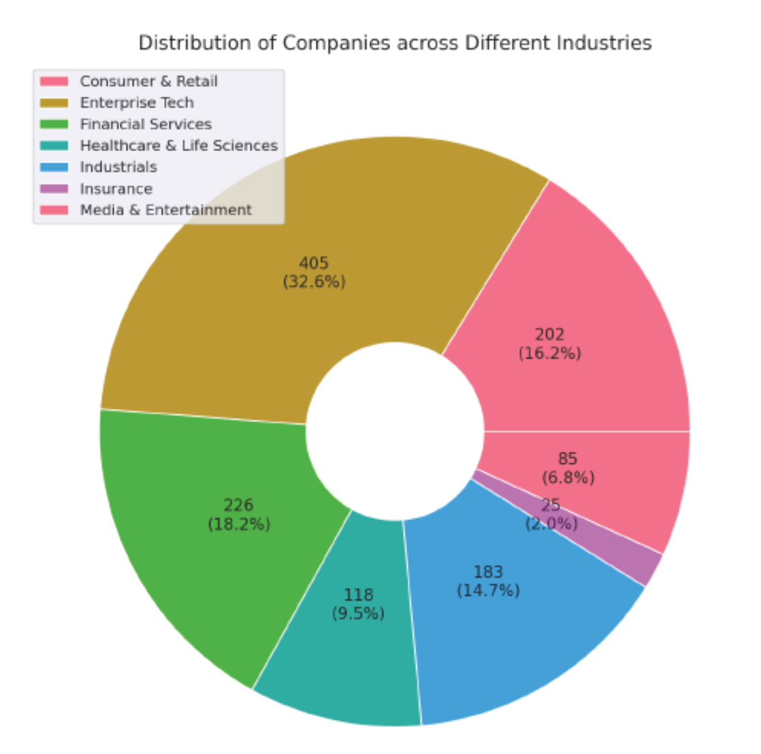

Bar Chart Analysis: *Distribution of Companies by Industry*

The chart displays the **number of companies** in each industry out of a total of **1,244 companies**. Here's the corrected breakdown:

| **Industry** | **Number of Companies** | **Percentage (%)** |
| --- | --- | --- |
| Enterprise Tech | 405 | 32.5% |
| Financial Services | 226 | 18.2% |
| Industrials | 202 | 16.2% |
| Consumer & Retail | 183 | 14.7% |
| Healthcare & Life Sciences | 118 | 9.5% |
| Media & Entertainment | 85 | 6.8% |
| Insurance | 25 | 2.0% |

Key Observations

Enterprise Tech (32.5%)

* The largest segment by far.
* Reflects the dominance of software, cloud, AI, and digital infrastructure companies.
* Indicates high scalability and investor interest in tech-driven solutions.

Financial Services (18.2%)

* A strong second place.
* Includes fintech, payments, lending, and wealth management platforms.
* Suggests ongoing disruption of traditional finance.

Industrials (16.2%)

* A surprisingly large share.
* Likely includes logistics, manufacturing tech, robotics, and supply chain platforms.
* Shows that innovation in physical infrastructure is gaining traction.

Consumer & Retail (14.7%)

* Slightly smaller than expected.
* Indicates a more selective or mature market compared to tech and finance.

Healthcare & Life Sciences (9.5%)

* A steady presence.
* Reflects the complexity and regulatory intensity of the sector, despite high impact potential.

Media & Entertainment (6.8%)

* A modest slice.
* May reflect challenges in monetization, IP, and platform saturation.

Insurance (2.0%)

* The smallest category.
* Suggests high barriers to entry or slower innovation cycles in insurance.

Conclusion

* **Enterprise Tech dominates** the startup landscape, accounting for nearly one-third of all companies—underscoring its central role in modern innovation.
* **Financial Services and Industrials** are also robust, reflecting strong momentum in fintech and infrastructure modernization.
* **Consumer & Retail and Healthcare** remain important but are relatively smaller, possibly due to market maturity or regulatory complexity.
* **Media & Entertainment and Insurance** are niche sectors with fewer players, potentially signaling untapped opportunities or structural challenges.

# 6.1.2 Distribution of Equity Funding across Different Industries

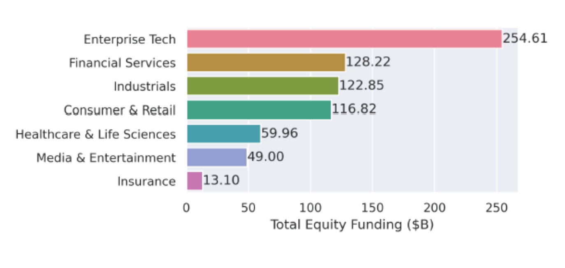

Chart Summary

| Sector | Equity Funding ($B) |
| --- | --- |
| Enterprise Tech | 254.61 |
| Financial Services | 128.22 |
| Industrials | 122.85 |
| Consumer & Retail | 116.82 |
| Healthcare & Life Sciences | 59.96 |
| Media & Entertainment | 49.00 |
| Insurance | 13.10 |

Key Insights

1. Enterprise Tech Dominates

* With $254.61B, Enterprise Tech has received nearly double the funding of the next closest sector.
* This reflects the massive investor appetite for cloud infrastructure, SaaS, AI platforms, and enterprise automation.

2. Strong Investment in Financial Services & Industrials

* Financial Services ($128.22B) and Industrials ($122.85B) are close contenders.
* Fintech continues to attract capital due to digital banking, payments, and blockchain.
* Industrials likely include robotics, logistics, and manufacturing tech—areas seeing innovation and automation.

3. Consumer & Retail Still Strong

* At $116.82B, this sector remains a major draw, especially with e-commerce, D2C brands, and retail tech.

4. Healthcare & Media Are Mid-Tier

* Healthcare & Life Sciences ($59.96B) and Media & Entertainment ($49.00B) show moderate funding.
* Healthcare may be underfunded relative to its societal importance, possibly due to regulatory hurdles and longer ROI timelines.

5. Insurance Lags Behind

* Insurance ($13.10B) is the lowest-funded sector, suggesting either:
  + Fewer unicorns in insurance
  + Slower innovation pace
  + Higher barriers to disruption

Conclusion

Investors are heavily favoring sectors with scalable, high-margin, and tech-driven business models. Enterprise Tech leads the charge, while Insurance remains a niche play. The mid-tier sectors may offer untapped potential for future growth.

# 6.2 Geographical Analysis:- Top Countries by Valuation

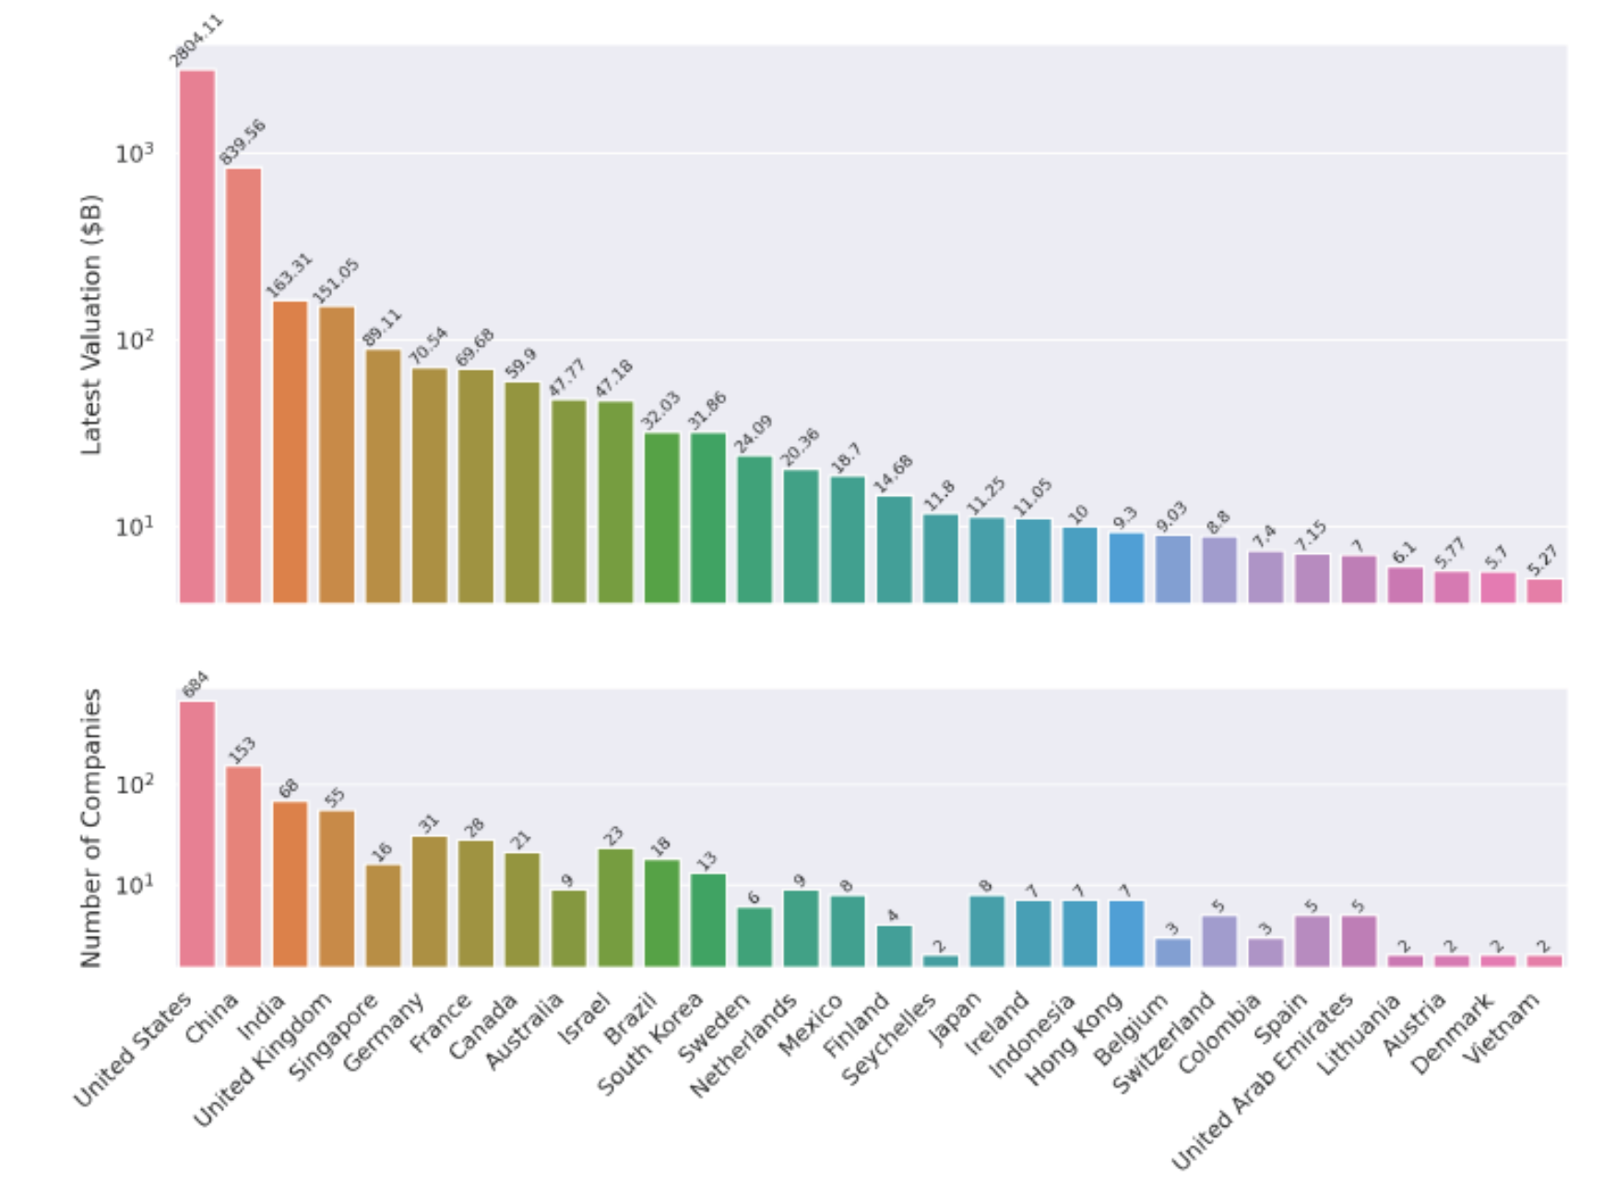

Top Countries by Startup Valuation & Company Count

Chart 1: Latest Valuation (in B$)

| **Country** | **Valuation (B$)** |
| --- | --- |
| United States | 2804.11 |
| China | 839.56 |
| India | 163.31 |
| UK | 151.05 |
| Germany | 70.54 |
| France | 69.68 |

* **The U.S. dominates** with nearly **3x** the valuation of China and over **13x** that of India.
* **China** is a strong second, but there's a steep drop-off after that.
* **Europe** (UK, Germany, France) holds a respectable middle tier.

Chart 2: Number of Companies

| **Country** | **Companies** |
| --- | --- |
| United States | 684 |
| China | 153 |
| India | 68 |
| UK | 55 |
| Germany | 31 |
| France | 28 |

* The **U.S. again leads** by a wide margin, hosting over **50%** of all companies shown.
* **China and India** follow, reflecting their growing startup ecosystems.
* **European countries** have fewer companies but still contribute significant valuation.

Key Insights

United States

* Leads in both valuation and company count.
* Suggests not just quantity but also high-value companies (e.g., unicorns, decacorns).

China

* Strong second in both metrics.
* High average valuation per company, indicating a mature and well-funded ecosystem.

India

* Fewer companies than China but still ranks 3rd in valuation.
* Indicates rising influence in global tech and startup innovation.

Europe (UK, Germany, France)

* Moderate number of companies with solid valuations.
* Suggests efficient capital deployment and possibly more late-stage companies.

Others (e.g., Israel, Brazil, Singapore)

* Smaller ecosystems but still producing high-value companies.
* May represent emerging innovation hubs.

Conclusion

* The **U.S. is the undisputed leader** in both startup volume and valuation.
* **China and India** are rapidly scaling, with China showing higher capital concentration.
* **Europe** maintains a strong presence with fewer but valuable companies.
* **Emerging markets** like Israel, Brazil, and Southeast Asia are punching above their weight in valuation per company.

# 6.3 Sector-Based Analysis (Top Sector)

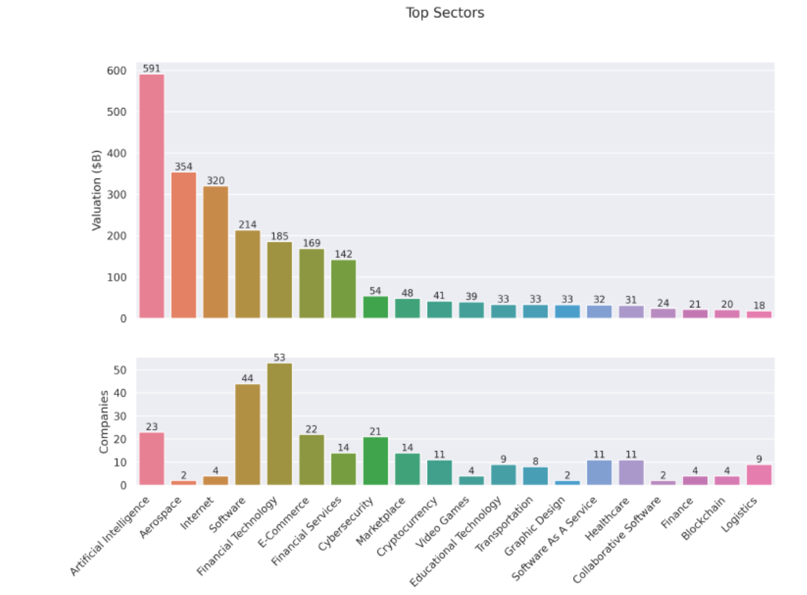

1. Chart 1: Total Valuation ($B)
2. Chart 2: Number of Companies

These charts help us understand which sectors are attracting the most capital and where the highest concentration of startups lies.

Chart 1: Total Valuation by Sector

This chart ranks sectors by the **cumulative valuation** of companies within each.

| **Rank** | **Sector** | **Valuation ($B)** |
| --- | --- | --- |
| 1 | Artificial Intelligence | 591 |
| 2 | Aerospace | 354 |
| 3 | Internet | 320 |
| 4 | Software | 214 |
| 5 | Financial Technology | 185 |
| 6 | E-Commerce | 169 |
| 7 | Financial Services | 109 |
| 8 | Cybersecurity | 142 |
| 9 | Marketplace | 54 |
| 10 | Cryptocurrency | 41 |

Insights:

* **Artificial Intelligence** leads by a wide margin, reflecting the explosive growth and investor enthusiasm in generative AI, machine learning, and automation.
* **Aerospace** and **Internet** follow, likely driven by a few high-value players (e.g., SpaceX, Starlink, or major platform companies).
* **Software, Financial Technology, and E-Commerce** show strong valuations, indicating their strategic importance in a post-pandemic, digitally connected world.

Chart 2: Number of Companies by Sector

This chart shows how many companies are active in each sector.

| **Rank** | **Sector** | **Number of Companies** |
| --- | --- | --- |
| 1 | Financial Technology | 53 |
| 2 | Software | 44 |
| 3 | Artificial Intelligence | 23 |
| 4 | E-Commerce | 22 |
| 5 | Cybersecurity | 21 |
| 6 | Financial Services | 14 |
| 7 | Marketplace | 14 |
| 8 | Cryptocurrency | 11 |
| 9 | Internet | 4 |
| 10 | Aerospace | 2 |

Insights:

* **Fintech and Software** dominate in company count, suggesting lower barriers to entry and broad applicability.
* **AI**, despite being #1 in valuation, has fewer companies—indicating high capital concentration per firm.
* **Aerospace and Internet** have very few companies but extremely high valuations, likely skewed by a few mega-unicorns.

Valuation Efficiency: Average Valuation per Company

Let’s calculate how much valuation each company commands on average:

| **Sector** | **Valuation ($B)** | **Companies** | **Avg. Valuation/Company ($B)** |
| --- | --- | --- | --- |
| Aerospace | 354 | 2 | **177.0** |
| Internet | 320 | 4 | **80.0** |
| Artificial Intelligence | 591 | 23 | **25.7** |
| Health | 167 | 20 | 8.4 |
| Biotechnology | 127 | 19 | 6.7 |
| Cybersecurity | 139 | 21 | 6.6 |
| Transportation | 132 | 17 | 7.8 |
| Software | 214 | 44 | 4.9 |
| E-Commerce | 157 | 22 | 7.1 |
| Financial Technology | 185 | 53 | **3.5** |

Conclusion

* **Artificial Intelligence is the most valuable sector overall**, with a strong average valuation per company—showing both depth and scale.
* **Aerospace and Internet** are outliers: few companies, but massive valuations—likely driven by a handful of dominant players.
* **Fintech and Software** have the most companies but the lowest average valuation per firm, suggesting high competition and market saturation.
* **Health, Cybersecurity, and Biotech** strike a balance between company count and valuation, indicating steady investor confidence.

# 6.4 Company-Based with Growth Rate Analysis

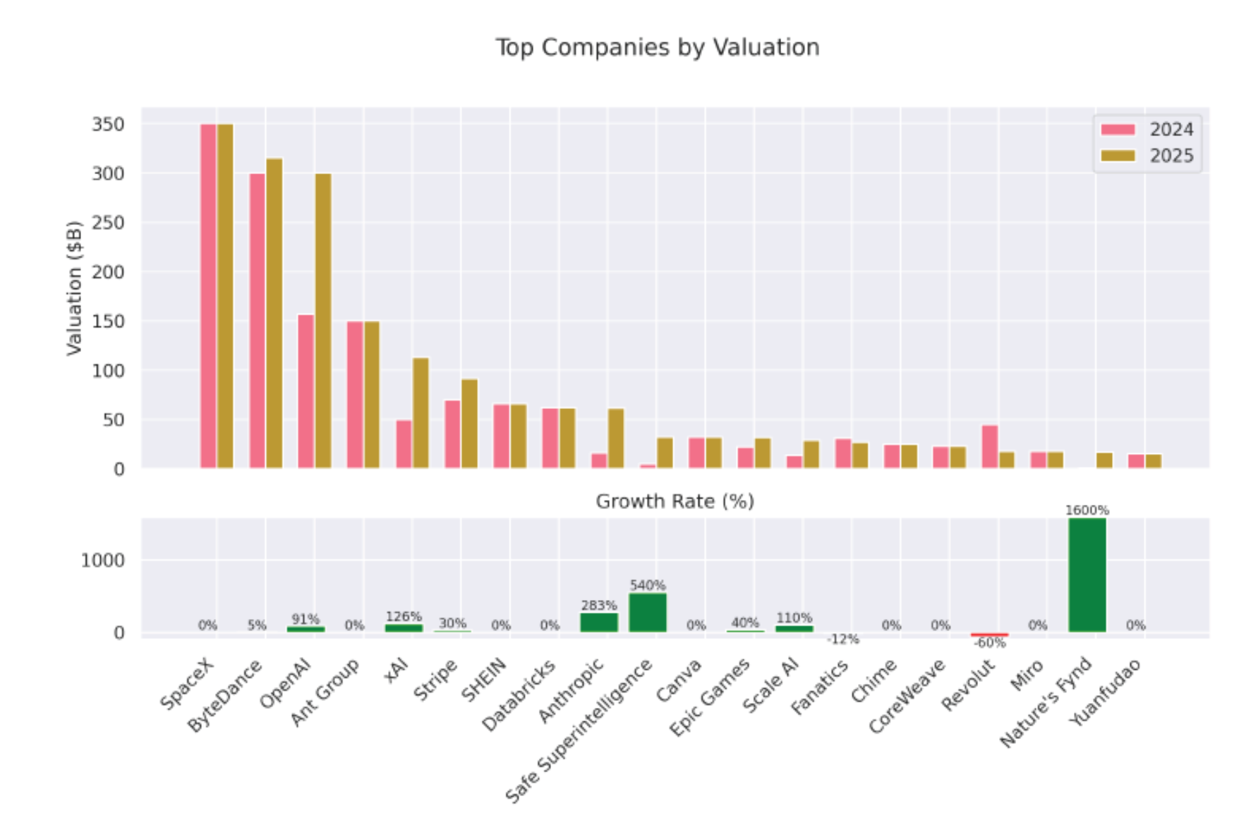

Top Companies by Valuation (2024 vs. 2025)

The upper section of the chart compares company valuations in billions of dollars:

* **Top 5 by 2025 Valuation**:
  1. **SpaceX** – remains the highest-valued company, unchanged from 2024.
  2. **ByteDance** – slight increase (~5% growth).
  3. **OpenAI** – major jump, reflecting a 91% increase.
  4. **Ant Group** – valuation remains flat.
  5. **XAI** – huge leap, up 126%.
* **Other notable players**:
  1. **Anthropic** and **Safe Superintelligence** show explosive growth.
  2. **Stripe**, **Epic Games**, and **Scale AI** also post solid gains.
  3. **Fanatics** and **Revolut** decline in valuation, with Revolut dropping sharply.

Growth Rate Highlights (Bottom Section)

| **Company** | **Growth Rate (%)** |
| --- | --- |
| Nature’s Fynd | **1600%** |
| Safe Superintelligence | 540% |
| Anthropic | 283% |
| Scale AI | 110% |
| XAI | 126% |
| OpenAI | 91% |
| Stripe | 30% |
| Epic Games | 40% |
| Fanatics | -12% |
| Miro | -60% |
| Others | 0% |

Observations:

* **AI companies dominate growth**: OpenAI, Anthropic, XAI, Scale AI, and Safe Superintelligence all post triple-digit growth.
* **Nature’s Fynd** (a biotech/alt-protein company) is the outlier with a staggering 1600% growth—possibly due to a new funding round or breakthrough.
* **Fanatics** and **Miro** are the only companies with negative growth, suggesting valuation corrections or strategic setbacks.
* Several companies (e.g., SpaceX, SHEIN, Canva, Chime) show **0% growth**, indicating stable but stagnant valuations.

Conclusion

* **AI is the clear growth engine** in 2025, with multiple companies seeing valuations more than double.
* **Nature’s Fynd** stands out as a breakout success, likely due to a major funding event or market shift.
* **Stability at the top**: SpaceX and ByteDance remain dominant but show little to no growth.
* **Caution flags**: Miro’s -60% drop and Fanatics’ decline suggest market corrections or internal challenges.

Remarks:

* 1. Nature’s Fynd自然之源是一家利用黃石國家公園的微生物生產蛋白質的食品公司，創造了肉類和乳製品替代品 這種名為「Fusarium strain flavolapis」的微生物，發酵後會生成一種富含蛋白質的物質，名為「Fy」。 Nature 's Fynd 利用 Fy 開發了諸如素食早餐餅和無奶優格等產品。
  2. Safe Superintelligence Inc. 或 SSI Inc. 是一家美國人工智慧公司，由 Ilya Sutskever（OpenAI 前首席科學家）、Daniel Gross（蘋果 AI 前負責人）和 Daniel Levy（投資者兼 AI 研究員）創立。

# 6.5 Top Investor Analysis

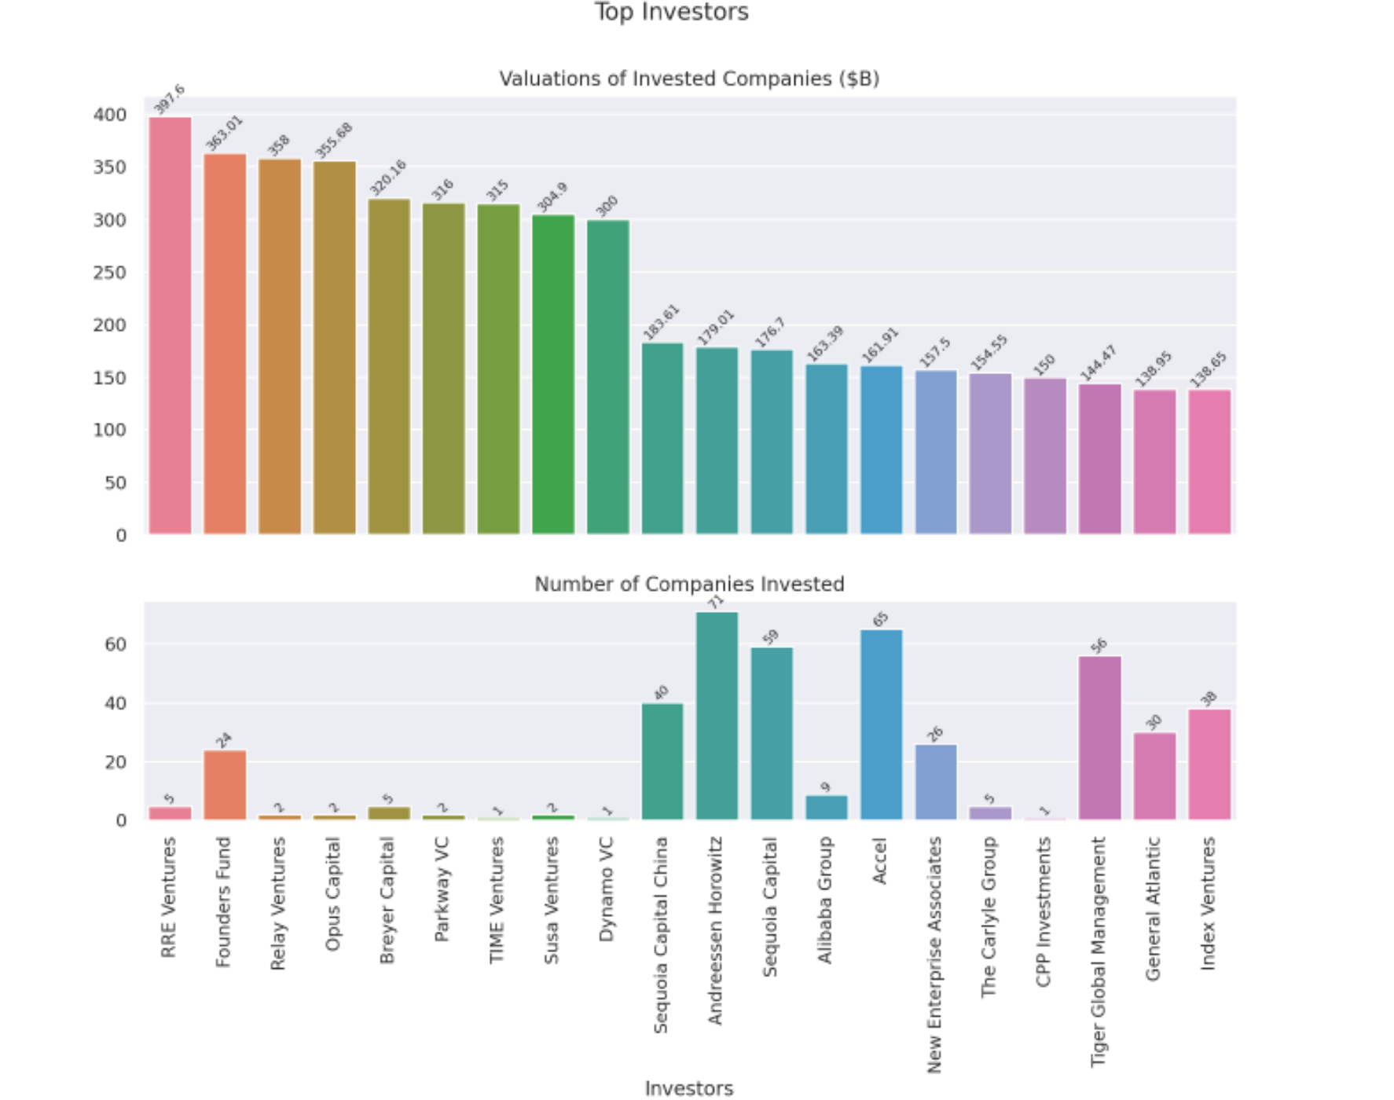

Chart 1: Valuations of Invested Companies ($B)

This chart ranks investors by the **total valuation of the companies** they’ve invested in.

Key Observations:

* **RRE Ventures** leads with $397.6B in total valuation, despite investing in only 5 companies.
* **Founders Fund**, **Relay Ventures**, and **Opus Capital** follow closely, each with over $350B in valuation.
* These top investors have relatively few investments, suggesting they backed **very high-value unicorns** (e.g., SpaceX, ByteDance, OpenAI).
* In contrast, **Andreessen Horowitz** and **Sequoia Capital** have lower total valuations ($179B and $176.7B respectively) but are known for **broad portfolios**.

Chart 2: Number of Companies Invested

This chart shows how many unicorns each investor has backed.

Key Observations:

* **Andreessen Horowitz** (71) and **Accel** (65) have the **broadest reach**, investing in dozens of unicorns.
* **Sequoia** (59), **Tiger Global Management** (56) **Sequioa Capitial China** (40) and also show strong diversification.
* **RRE Ventures**, despite leading in valuation, has only 5 investments—suggesting **high-conviction, high-impact bets**.
* **Time Venture** has only 1 investment, but it contributes significantly to its valuation total ($315B), indicating a **single mega-unicorn**.

Conclusion

The charts reveal two dominant investment strategies: **concentrated bets on mega-unicorns** (e.g., RRE Ventures, Founders Fund) and **broad diversification across many startups** (e.g., Sequoia Capital, Andreessen Horowitz). Both approaches can yield high returns, but the former relies on picking outliers, while the latter spreads risk across the ecosystem. For founders, this also signals which investors are more likely to back early-stage moonshots versus those who scale proven models.

# 6.6 Top Founder Analysis

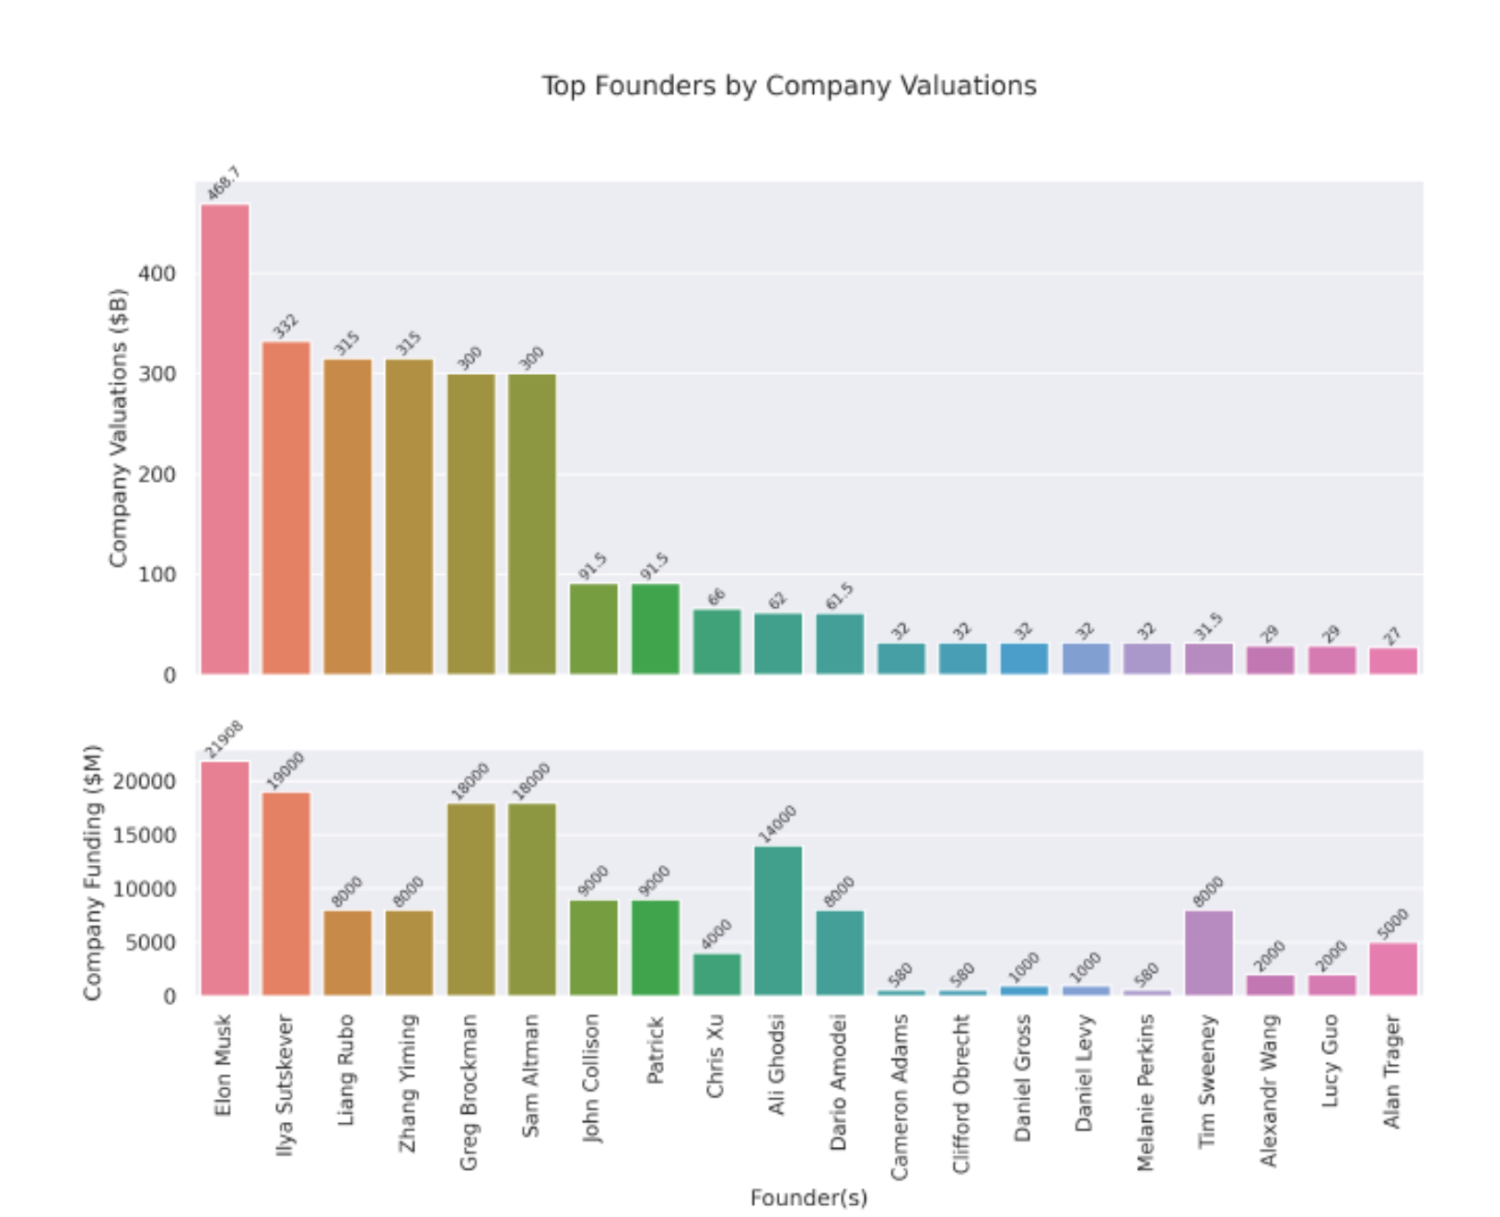

Key Observations

* **Recent Founders, Massive Valuations:**   
  Companies founded between **2010–2016** dominate the high valuation range (above $10B–$50B). This period seems to be a hotbed for unicorn creation, especially in tech and finance.
* **Outliers Like SpaceX & ByteDance:**   
  These companies—though founded earlier (e.g., early 2000s)—show exceptionally high valuations **($300B–$350B)**, suggesting longer-term strategic growth, continual funding, and massive scale.
* **Quick Climbers:**   
  Some unicorns founded in the **past 5 years** (2020 onward) like **Anthropic, xAI, and Perplexity** are already seeing multi-billion dollar valuations (approaching or crossing $10B), implying investor excitement in emerging tech like AI.
* **Clustering:**   
  There’s a noticeable clustering of unicorns with valuations ranging between **$10B–$30B**, particularly among those founded between **2012–2018**. It reflects a time when VC funding surged and industries like fintech, SaaS, and retail tech boomed.

Conclusion

* The last decade has been fertile ground for unicorn growth, especially in AI, fintech, and enterprise software.
* **Younger unicorns** reaching high valuations quickly (within 2–4 years) point to evolving investor behavior—favoring disruptive innovation over long-term scaling.
* Legacy unicorns (early 2000s) reaching peak valuations underline the **power of sustained growth and strategic reinvention**.

# 7. Significance

This project demonstrates proficiency in Python-based data analysis and visualization, showcasing the ability to transform raw data into actionable insights. By analyzing unicorn companies, the project contributes to understanding the dynamics of high-growth startups, which are critical to innovation and economic development. The visualizations will serve as powerful tools for communicating findings to stakeholders, supporting strategic decision-making in investment, entrepreneurship, or policy development.

# 8. Results and Visualization

# 9. Conclusion

# 10. Appendix

**The End**